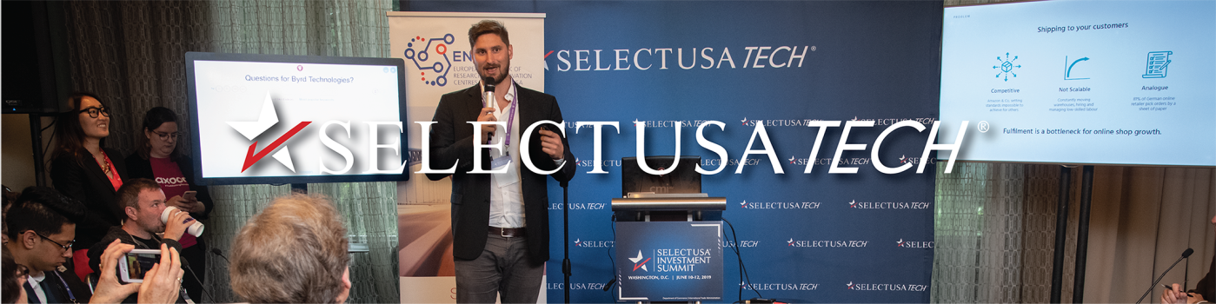

Startup Pitch Sessions
Early-stage and startup tech companies can apply to make their virtual pitch in front of an audience of Investment Summit attendees and a panel of 4-6 judges, including venture capitalists, corporate investors, representatives from startup ecosystems, and industry experts. All pitches are limited to four minutes, followed by two minutes of Q&A from the panel of judges. Each selected company will participate in one of seven sessions in the following categories:
- Aerospace
- Cybersecurity
- e-Commerce
- FinTech
- MedTech
- Software
- Other (any tech industry not listed above)
Apply now to participate in the Virtual Startup Pitch Sessions at the 2021 SelectUSA Investment Summit. Applications are due by April 30, 2021.
Note: Only companies approved to attend the 2021 SelectUSA Investment Summit under the SelectUSA Tech program are eligible to participate in the pitching sessions. Please apply to attend the Investment Summit before applying to pitch.

Startup Pitch Session Application Process
Applications due by April 30, 2021
Pitch: 4 minutes pitch + 2 minutes of Q&A
The pitching application will be posted soon. The application will include the questions listed below. Pitching applications must be submitted by 12:00am (midnight) EDT on April 30, 2021.
Who: Company Name, Project or Initiative, & Team
What is your company name? What is the new initiative or project? Who is on the team?
Why: The Problem
What problem are you trying to solve? How is your solution different from other solutions? What is the market opportunity?
- Define your market (global & specific to the U.S.)
- Total market size, your niche, and U.S. market potential
- Competitors
- Trends
- Market forces
What: Your Solution / Product / Technology
- Describe your product
- Its competitive advantage
- 4 P Marketing Mix (price, product, promotion, & place)
How: Business Model and Achievements
Please describe how you are planning to make money, be profitable, and be scalable. Achievements may include:
- Describe your timeline and milestones to date
- Existing customers and other partnerships
- Funding already obtained and plans for future funding rounds
- Intellectual Property (IP) protections (if applicable)
- Other relevant achievements
When: Next Steps
- What are your next steps broadly and for the U.S. market specifically?
- What is your ask to the audience? What are you looking for?

Application Review Criteria
The SelectUSA Tech planning team will select up to 60 companies participating in SelectUSA Tech that submit a pitching application by 12:00am (midnight) EDT on April 30, 2021. You may include supporting documents as necessary.
Pitch proposals will be judged on the following factors:
1. Completeness.
2. Adherence to the requested format (who, why, what, how, when), with allowances for some creativity.
3. Timeliness of submission (Proposals received earlier in the process will receive a higher score).
4. U.S. market readiness (Is the product/design/concept well-developed and ready for entry into the U.S. market?).
We may contact applicants directly if more information is needed.
By applying, you authorize the U.S. Department of Commerce to share submitted information with partners who are a part of the review committee.

Judging the SelectUSA Tech Startup Pitch Sessions
Pitches will be judged on the following criteria:
Practicality – How reasonable and scalable is the concept/product?
Creativity – How different is the product or idea from others already on the market?
Market Analysis – Is there a genuine need for the concept/product in the market? How well is the target market defined?
Impact – What potential impact will the concept have on the U.S. (and other) market(s)?
Experience/Management – How well prepared is the presenter and their team to execute the concept? Do they have the necessary experience to succeed?
Strategy – Does the project and the team have a clear plan, including a means to measure success?
Presentation Flow – How well is the concept presented? Did the presenter complete the pitch within the 4 minutes allotted? Was the presentation compelling and concise?

